**Computer Applications Technology**

**Moses Maren**

**Grade 10**

**June 2024**

**Paper 1 Practical**

June 2024

Time: 1,5 hours Marks: 50

**Examiner: Ms Mofokeng**

**Moderator: Mr Dakome**

This paper consists of 6 pages (title page included)

**Instructions and information**

1. Note that you will not be allowed to leave the examination venue before the end of the examination period.
2. Save your work at regular intervals.
3. Read through each question before answering or solving the problem. Do not do more than is required by the question.
4. Note that no printing is required.
5. During the examination you may make use of the help facilities of the programs which you are using. You may not use any other resource material.
6. Note that if data is derived from a previous question which you cannot answer, you should still proceed with the questions that follow.
7. Formulas and/or functions must be used for all calculations unless specified otherwise – in other words, do not manually calculate and type in the answers!

***Please note:***

You will receive together with the question paper an examination folder called **DATA Gr10**, which contains the following files:

1Entry Word processing file

2Apple Image

2Challenge Word processing file

2Tips Word processing file

3Admin Spreadsheet

***Theme: Fitness Challenge 2022***

*The school is planning to introduce a fitness program. Various documents have been created that need to be completed.*

**Question 1 – Word processing (I)**

*A document has been created which people will use to sign up for the fitness program.*

Open the **1Entry** document.

1.1 Change the following page settings:

* Change the page size to A4.
* Change the margins to the ‘Normal’ setting.
* Change the page colour to white.
* There is currently a page border only on page 1.

Apply the existing page border to the whole document (i.e. to page 1 and page 2). (4)

1.2 Locate the text ‘Dear Entrant’ at the top of the document.

Change the font of the text to Tahoma, 23 pt. (2)

1.3 Locate the text highlighted in green on page 1.

* Remove the green highlighting.
* Add a Drop Cap that appears as shown below.

The distance of the Drop Cap from the text must be 0.2 cm.

 (4)

1.4 Locate the picture at the bottom of page 1.

Display the picture in its original colours. (1)

1.5 Locate the numbered list in red under the heading ‘Reading and emotions’.

Format the list so that it appears as shown below, without the border, by following the instructions under the screenshot (do not change any colours):

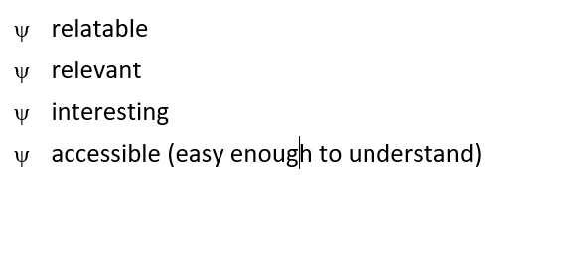

*Do the following:*

* Convert the list to a bulleted list, using character code 79 from symbol (hex) for the bullet character.
* Format only the bullet characters in bold.
* Position the bullets as shown above.
* Set the hanging indent to 0.8 cm.
* Ensure that the bulleted list is displayed as shown above. (5)

**Save and close the 1Entry document. [16]**

**Question 2 – Word processing (II)**

*A document has been created to introduce the program to parents and learners.*

Open the **2Challenge** document.

2.1 Locate the bulleted list under the heading ‘General Benefits’.

* Change an indentation setting to display the bullets against the left margin.   
  (Do not change the distance between the bullets and the text.)
* Display last two items in the list as follows:

 (2)

2.2 Locate the text (paragraph) in red under the heading ‘Losing Weight’.

* Insert the picture **2Apple** at the left side of the paragraph.
* Make the necessary changes so that the picture and the paragraph appear as shown below, without the border. (Do not change any colours.)

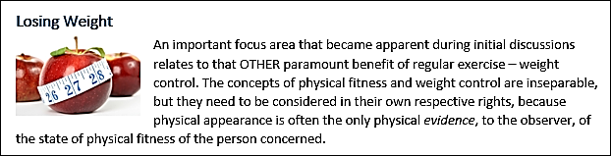 (4)

2.3 Locate the picture and the text box (shape) containing the text ‘Name Surname’ under the heading ‘Certificates’.

* Ensure that the picture and the text box can be selected with a single mouse click.
* Display the picture and the text box as follows:

(3)



Name  
Surname

2.4 Locate the text in red under the heading ‘Items to Purchase’.

Display this text as shown below. (Do not change any colours.)

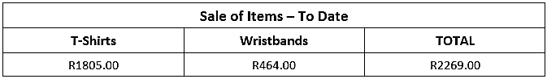 (2)

2.5 Format all instances of the word ‘head’ in bold AND italic (***like this***).

Ensure that words such as ‘ahead’ and ‘headway’ will not also be formatted in bold and italic. (3)

2.6 Insert automatic page numbers in the header of the document. You may use any format for the page numbers. (2)

**Save and close the 2Challenge document. [16]**

**Question 3 – Spreadsheet**

*A spreadsheet is being used to help with administration.*

Open the **3Admin** spreadsheet.

3.1 Make the following formatting changes:

3.1.1 Merge and centre **cells B6:D6**. (1)

3.1.2 Change the height of **row 6** to half its current height. (1)

3.1.3 Middle-align (vertically) the content of merged **cell B7**. (1)

3.1.4 Format merged **cell C7** so that it appears as shown below. (Do not change any colours or fonts.)

 (2)

3.2 Ensure that, if the worksheet were to be printed, it would be printed

* on A4 size paper
* with gridlines.

*Note:* Do NOT print anything! (2)

3.3 Insert a function in **cell I2** to calculate the average height (**column E**) of the entrants.

Format the result to display with 1 decimal place. (3)

3.4 An attempt was made in **cell I3** to determine the shortest entrant (**column E**), but an error message is returned.

Correct the function in **cell I3** so that the desired result is returned. (1)

3.5 Change the format of the numbers in **column A** to display as   
0001, 0002, 0003 ... 0027 (2)

3.6 Entrants purchased a T-Shirt (cost stored in **column H**) and/or a Wristband (cost stored in **column I**).

Insert a formula or a function in **cell J10** to calculate the subtotal (combined cost of the T-shirt and the Wristband) for *Paxton, S*. (2)

3.7 The amounts in **column J** exclude VAT.

*Do the following:*

* Change the existing formula in **cell K11** to calculate the TOTAL (plus VAT) owed by *Pretorius, E*. (The VAT percentage rate is stored in **cell K3**, which has an existing cell name of ‘VAT’.)

Use the existing cell name (i.e. *VAT*) of **cell K3** in your formula.

* Copy the formula in **cell K11** to **cells K12:K35**. (3)

**Save and close the 3Admin** **spreadsheet. [18]**

**TOTAL: 50**